Name: ____________________________ Date: ________________ Block: __________

Mitosis—Internet Activity

In this internet lesson, you will visit several internet sites to review the steps of mitosis and view video simulations of cell division. You will also view an onion root tip and calculate the percentage of cells at each of the stages of cell division.

Mitosis Tutorial: <http://www.cellsalive.com/mitosis.htm>

1. Which stage does the following occur?

Chromatin condenses into chromosomes-____________________________________

Chromosomes align in center of cell- ________________________________________

Longest part of the cell cycle-______________________________________________

Nuclear envelope breaks down- ____________________________________________

Cell is cleaved into two new daughter cells-___________________________________

Daughter chromosomes arrive at the poles- __________________________________

Watch the video carefully

1. The colored chromosomes represent chromatids. There are two of each color because one is an exact duplicate of the other.

How many chromosomes are visible at the beginning of meiosis? _________________

How many are in each daughter cell at the end of mitosis? ______________________

The little green T shaped things in the cell are? ________________________________

What happens to the centrioles during mitosis? _______________________________

1. Identify the stages of these cells:

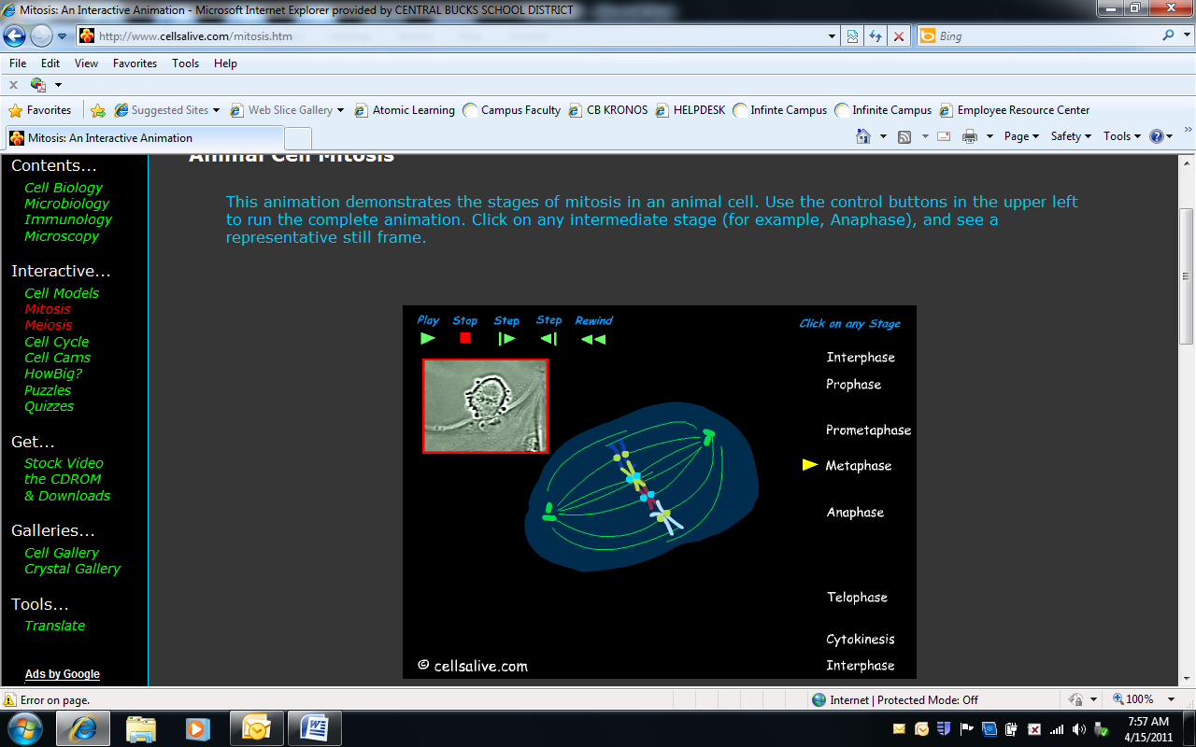 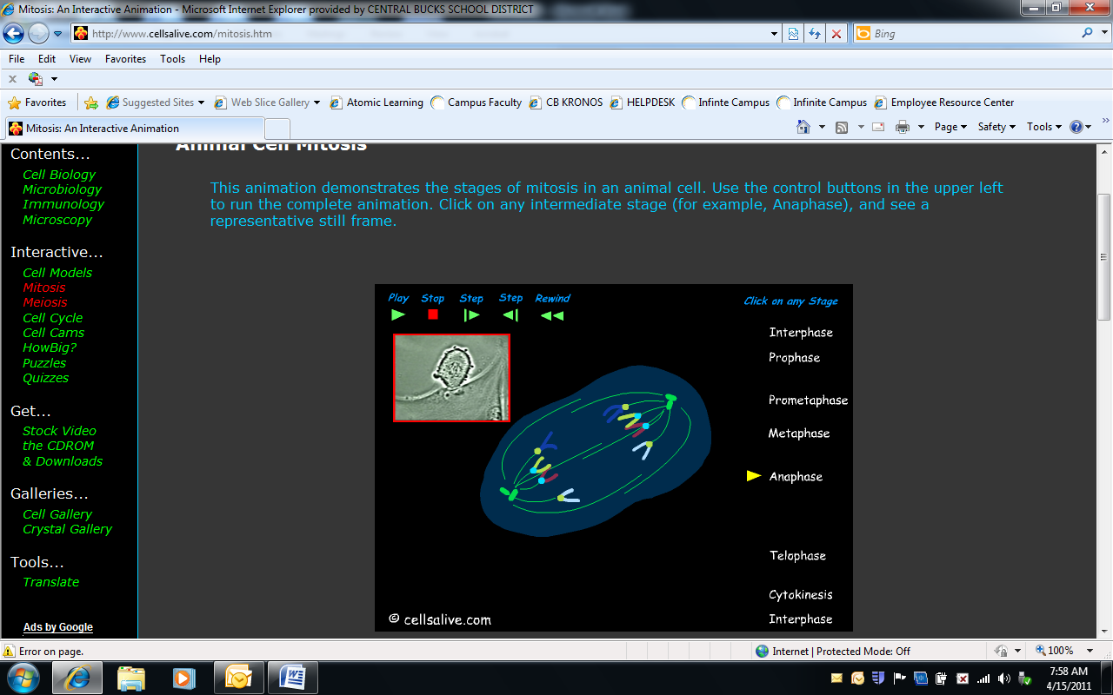 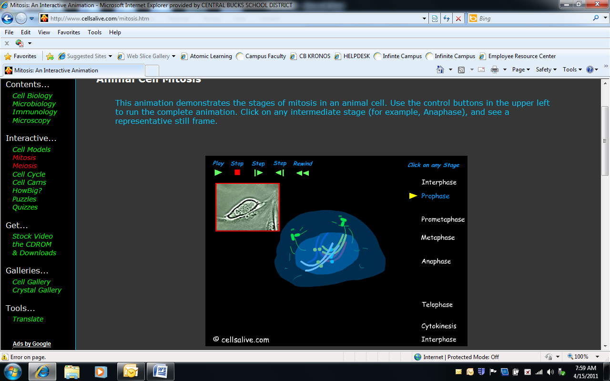

____________________ ____________________ _________________

Onion Root Tip Activity

In this activity, you will be presented with cells from the tip of an onion root. You will classify each cell based on what phase it is in. At the end you will count up the cells found in each phase and use those numbers, to predict how much time a dividing cell spends in each phase.

1. Go to the web site [www.biology.arizona.edu](http://www.biology.arizona.edu).
2. Click on the icon that says **Cell Biology**. (left hand side under activities)
3. Click on **Online Onion Root Tips**.
4. Go to the “Online Onion Root Tips- Determining time spent in the different phases of the Cell Cycle.” Note the animation. Continue to click on “next” until you see the chart below.
5. Identify the phase of each cell diagram and make an appropriate tally in each box in the chart below. Complete the chart.

|  |  |  |  |  |  |  |
| --- | --- | --- | --- | --- | --- | --- |
|  | Interphase | Prophase | Metaphase | Anaphase | Telophase | Total |
| Number of  Cells |  |  |  |  |  | 36 |
| Percent of  Cells |  |  |  |  |  | 100% |

Navigate back to the **Cell Cycle and Mitosis** of the Arizona web site. Click on cell cycle and read through the material to answer the following questions.

Define Cancer: _____________________________________________________________________________________

_____________________________________________________________________________________

What is p53?

_____________________________________________________________________________________

_____________________________________________________________________________________

What happens if p53 is mutated?

_____________________________________________________________________________________

_____________________________________________________________________________________

Nobelprize.org

Go to the following web site and explore the activities associated with this site.

<http://nobelprize.org/educational/medicine/2001/cellcycle.html>

1. How many cells are replaced in our bodies every minute? _____________________________
2. Give two examples of cells and their rate of division. __________________________________

_____________________________________________________________________________

1. When a cell dies, what is the function of a receptor? __________________________________

_____________________________________________________________________________

1. What is the function of CDK and Cyclin? ____________________________________________

_____________________________________________________________________________

1. List the proper steps in the “Control of the Cell Cycle” _________________________________

__________________________________________________________________________________________________________________________________________________________________________________________________________________________________________

1. Define mutations and explain what may happen to chromosomes. ? ______________________

______________________________________________________________________________

______________________________________________________________________________

1. Define tumor. __________________________________________________________________

____________________________________________________________________________________________________________________________________________________________

1. View the film.